**Indian Institute of Technology Bombay**

**Department of Aerospace Engineering**

**AE706 – Computational Fluid Dynamics**

Assignment 2 Report

Report By:

Mayank Bajaj

Roll No.- 210010039

Course Instructor: Prof. J. C. Mandal

February 20, 2024

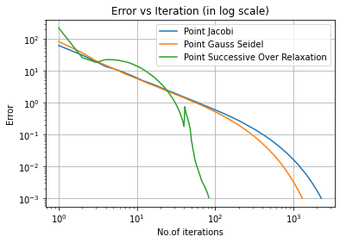

Number of iterations for convergence using Point Jacobi: 2280

Number of iterations for convergence using Point Gauss Seidel: 1298

Number of iterations for convergence using Point Successive Over Relaxation: 84

**Comments:**

We see that Point Successive Over Relaxation converges in least number of iterations while Point Jacobi method converges in the greatest number of iterations. This agrees with our theoretical calculations. The steepest slope is for PSOR suggesting higher order truncation error while Point Jacobi has the gentlest slope suggesting lower order truncation error. This agrees with out theory because for Point Jacobi we just use the data of the previous time step, whereas Point Gauss Seidel uses a combination of both the previous time step and current time step. Point Successive Over Relaxation goes a step further and does a weighted addition of new step time step with the previous time step.

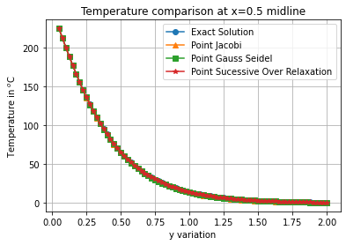

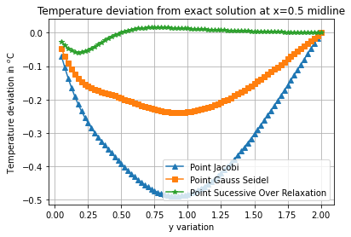

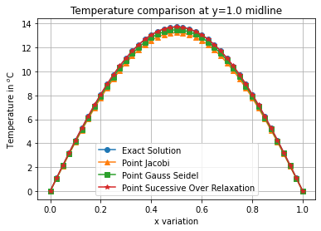

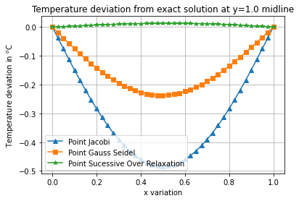

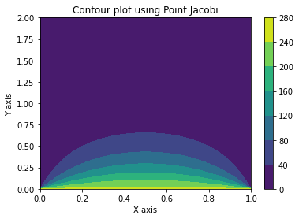

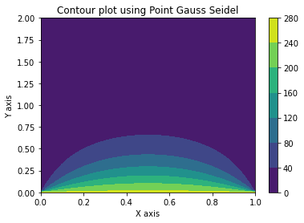

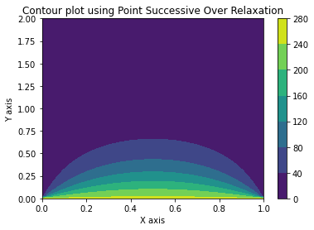

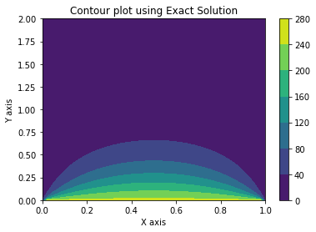

**Conclusion:**  
We see that the errors using different method and observe that Point Successive Over Relaxation always gives the least deviation from the exact solution, next comes Point Gauss Seidel and the most deviation is for Point Jacobi method. This further agrees to our theoretical expectations proving that PSOR has highest order truncation error and Point Jacobi has lowest order truncation error. The contour plots for the temperatures using the different methods also closely agrees with each other and the exact solutions.